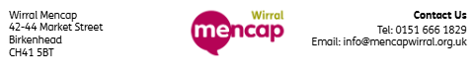
Name: _____________________________________________________________________________
Telephone Number: _________________________________________________________________
Email address: _____________________________________________________________________
Item Number | Quantity | Photo Number | Price | Total (£)
 |  |  | Order total:
Payment Method
Cash
Card
Would you like to make an extra donation?
Yes
No
Donation amount: ____________

